LRT meeting notes November 24th, 2016
Present
Andrew Hope, Metrolinx
Michael Hodge, Metrolinx
Don Forbes, Metrolinx
Tania Zimmerman, Metrolinx
Kelly Anderson, City of Hamilton
Trevor Horzelenberg, City of Hamilton
Jennifer Fraser, Treasurer KNA
Mark Stewart, Member at Large, Chair Development Committee, KNA
Doreen Sternman, Development Committee, KNA
Metrolinx delivered the same presentation that was shared at our Development Committee Meeting in October 2016 (attached).
Approx 37 neighbours in addition to the above mentioned
Question was asked about where Frid Street extension is to run now. The answer was shown in the attached presentation. The design of the street including size, bike lanes etc are the same as the last Environmental Assessment, it has simply been re-aligned.
After the presentation, questions were asked from the audience.
- Can we ask to be involved in construction design process and have the ideas included where possible. Prior to design phase after contract is awarded?
- A Community Liaison Committee will be set up to work with the developer through the construction phase of the OMSF project – We need to ensure that a CLC is struck specific to the OMSF project and not lumped into the entire LRT.

- Can the bridge be widened to include pedestrian / bike facilities, etc? as well as LRT?
- The bridge will be developed as needed to handle the LRT. Should further upgrades be requested but not required, they may be completed through the City’s budget. The LRT project will not pay for bridge upgrades that it does not require for LRT.

- What are the hours of operation?
- not sure yet, vehicles would need to be online by 6:00 am or so. This would mean that transit cars would be leaving the OMSF just before this to get to their route. The OMSF will operate overnight to maintain and wash light rail vehicles.

- Are you taking into account the tractor trailer use for Frid? Will Metrolinx ensure trucks are removed from Aberdeen when completed as it was planned?
- The plan for Frid street has not changed. If the original EA was designed to redirect trucks from Aberdeen then that is what should happen again. The LRT project will not change the original plans for Frid (except to realign it as noted).

- Noise concerns re squeals in the train yard. What is Metrolinx doing about it?
- Noise Studies are being completed now to develop a baseline for decibel levels in the area. No further comments were made regarding what may be done about increased noise from the light rail vehicles and OMSF operation.

- Can we have a sound barrier / wall? What other kinds of noise barriers could be considered? Will Metrolinx make sure that their answer to mitigate OMSF noise does not increase CP rail noise? Perhaps in conjunction with CP?
- Appropriate sound barriers will be developed if needed. A discussion continued about the increased noise from the CP rail line and that the CP was supposed to put in a sound barrier between the rail line and the residential neighbourhood when it went in. This was not done. The reason why was not clear. The request is that with the increase in sound from the OMSF, could this wall be reconsidered to help the residents with both the noise from CP rail and the OMSF.

- Will a vibration monitoring and study be completed?
- A vibration study is being completed currently. Residents were concerned about further vibrations from light rail vehicles due to the damage already done from the CP freight cars. Metrolinx felt that the much lighter light rail vehicles will not be an issue compared to CP’s freight cars and diesel engines.

- Will there be noise monitoring after the construction when in operation.
- Yes.

- Will an Environmental Assessment be completed and how will any potentially hazardous materials be handled?
- A full Environmental Site Assessment (ESA) is being completed for the site. Residents are also welcome to submit any questions or comments to be included and addressed in the amendments to the Environmental Project Report if they wish – deadline for comments and feedback is February 3, 2017. Potentially hazardous materials will be handled as per the Ontario Building Code and as needed for permits etc.

- Existing City cycling plan: how will it be integrated, maintained, modified
- All existing plans remain in effect and will be implemented by the City as planned. The LRT Office will work with the City to develop cycling lanes in the areas that are affected by the LRT project.

- How long is a train, how many are typically coupled?
- Metrolinx expects that LRT service will start as a 1 car operation and will expand as ridership increases to 2 car trains.

- Water pressure assessment. What is plan to identify and address pressure issues?
- This is a City issue. Metrolinx understands that there is sufficient pressure to operate their facility. Having said that, the train washing system uses very little water because it recycles it between washes. City representatives noted that water pressure will be maintained.

- When are cars washed?
- Typically, light rail vehicles are washed as they return to the OMSF when finished operation for the day.

- Pedestrian walkover/crossover presented through MIP. Part of MIP design. Where does this stand now?
- The pedestrian bridge was not part of the original LRT plans; only future interests of MIP. Given the change in positioning etc. this may not be feasible, but can be looked at.

- Why were the past streetcar tracks taken out and why are we embracing it now?
- The City’s transportation needs have changed over time.

- Impact to business during and after construction. What will be done about it?
- No businesses should be affected by the construction of the OMSF, however, the LRT project has a plan to minimize impact for businesses along the route.

- How will the road look different once the tracks are installed? How do the trains flow with traffic to get on and off the line?
- The light rail vehicles will turn off the dedicated track at Longwood and Main, and use track embedded into the road way along Longwood and Frid. The tracks will be embedded into the road so that cars will be able to share the lanes with the light rail vehicles. This is the same way streetcars operate in Toronto, where there is no dedicated track.

- Regarding the “Samee Metals” site. The City turned down big box retail development on the site in the past. The City and MIP wanted higher purpose for the land. Now OMSF. This seems to have lost the vision? How is this past vision to be embraced? For example, could a mass transit research centre be developed in conjunction with McMaster?
- The over 70 Jobs offered at the OMSF are high paying skilled positions that fit into the City’s general employment land-use for this site. Nothing else is planned at this time.

- Design. Is design part of the criteria to be followed? How do you ensure it’s not ugly? Does it still need to go through a City site plan approval? If so what is this process? Is it a public process? Do the drawings get presented to the public? If so when?
- Design Excellence is part of the criteria for the contract. The MIP Master Plan criteria will also be included as part of the tender package. The City’s site plan approval process does not involve any statutory public meetings, but Metrolinx will return to the KNA to provide updates as part of the design process. The timing is not fully known yet.

- What acreage is left at MIP? Will this be a deterrent to advanced employment, will it still attract the right kind of business and innovation?
- MIP retains the original 53 acres that it started with, how much more (if any) it will have has not yet been determined as the discussion about the land purchase has not been completed. The West Hamilton Innovation District remains an advanced innovation area for the City and plans continue to focus on developing this entire area for innovation.

- Light assessment to be done? What is it like?
- Yes a light level assessment will be part of the amended Environmental Project Report. Lighting is designed to point down towards the tracks and not leak out beyond the OMSF yard. Pictures are available of typical lighting in the presentation.

- What are the operating hours?
- The OMSF operates 24/7.

- What kind of functions will happen in off hours-24hrs?
- Overnight washing and maintenance / repairs of the trains. Staff arriving and departing for shifts, particularly early in the morning.

- What is the contamination assessment process?
- Core samples are taken throughout the site to determine if there are any hazardous materials onsite. Mitigation, or remediation plans are made depending on what (if anything) is found and the appropriate regulations.

- Will contamination findings delay the project?
- Unknown, but they should not, given the lead time available.

- What other sites were looked at?
- Over 30 sites were reviewed but one of the most important criteria is proximity to the main LRT line, along with the minimum required area of 6-8 hectares (15-20 acres). This location is the only one that met all of the criteria well.

- Construction dust, noise -who takes care of it and addresses concerns. The Rez cited as a failure of how construction has not been contained. What is the process? How do we address concerns?
- The CLC will be the main contact to help ensure construction issues are dealt with. Dust, noise attenuation and mitigation are also addressed in the tender and is part of the contract requirements.

- Can there be a community liaison committee?
- Yes

- Can there be an R and D component to the site? Employment component to the site? Fit the vision of the MIP site.
- There are no discussions at this time.

- More OMSF sites in the future? Will this site be expanded for future use? What is the process?
- The OMSF is sized to maintain the entire B-Line and the A-Line spur as it expands in the future. However, additional lines such as the full A-Line will require a new, second OMSF site. A site that is close to that line.

- What is the shelf life of the site?
- The OMSF will serve the initial 30-year period of LRT operation and beyond.

- Power outages are common in the area. Back-up generators on site? How do you establish power need and what capacity is needed?
- Power requirements are developed and reviewed by Horizon Utilities, and Metrolinx has been assured that the power capacity is available for the OSMF.

- Where does water and sewage come in?
- Water and sewer lines will come in from Frid Street. Larger pipes were installed during the CANMET upgrade. These can be extended to the site.

- Budget costs. Land should be expropriated not negotiated to keep costs in check. Stadium cost too much due to negotiations.
- Whether land is acquired through negotiation or expropriation, Metrolinx is committed to providing fair compensation in accordance with provincial legislation.

- What is the timing of Frid St extension?
- The Frid Street extension will be built at the same time as the OMSF. The OMSF will be one of the first elements of the project to start construction.

- Waterloo, Leslie, Eglington sites-any studies to show impact to property values?
- None that Metrolinx is aware of.

- Will there be a rail spur from CP Rail added to bring materials and light rail vehicles in to the site? If so is this noise to be abated-same as construction vehicle noise-will it be abated? Who decides what will be done?
- A CP Rail spur to service the OMSF is not planned as part of the LRT project.

- Traffic signal at Frid and Chatham to be installed? Is it part of the Frid St EA?
- Outside the scope of the LRT project, but if it was part of the original EA, then it will be completed as required by the City.

- Can the underground creek be renaturalized as part of the project? Has it been considered to date?
- Renaturalizing the creek has not been considered. There are no plans to open it from the culvert under the Samee Metals building. However, this is the time to bring this idea forward for consideration through the environmental assessment process.

- How will streetscaping be addressed? Will there be an artist rendering that can be reviewed/presented to the public?
- Streetscaping is being addressed in the tender document to meet the City’s requirements. Design ideas will be made available for comment as the project is developed.

- How does the city afford this once the project is done? What does the city budget pay for, Metrolinx pay for?
- Metrolinx is responsible for 100% of the capital costs for the LRT project (e.g. construction, equipment, vehicles, etc.). Funding the operation of the LRT system will be subject to the negotiation of an Operations and Maintenance agreement between the Province of Ontario and the City of Hamilton.

- Is the chimney, steam plant included?
- No, the steam plant is part of the existing MIP development and is not part of the OMSF.

- Procurement process-how does this work?
- It is anticipated that the Hamilton LRT project will be delivered as a Design, Build, Finance, Operate, Maintain (DBFOM) contract using the Alternative Financing and Procurement (AFP) delivery model.
In early 2017 Metrolinx and Infrastructure Ontario (IO) will issue a Request for Qualifications (RFQ) to prequalify teams to design, build, finance, operate and maintain the Hamilton LRT project. The RFQ is the first step in the procurement process to select a team to deliver the project. An evaluation of RFQ submissions will result in teams being prequalified; these teams will then be invited to respond to a Request for Proposals (RFP) in Summer 2017. The RFP submissions received from the teams will be evaluated and the successful team will be selected to design, build, finance, operate and maintain the project.

- Will there be a grade change of some sort on Frid? How will this be addressed? What will the building be knowing that grading will be required. Can we ensure that it is not higher than the buildings?
- Yes, there are grade changes across the OMSF site that will need to be addressed through engineering and design.

- What is the revenue sharing model once live? How does third party financing work between Metrolix and the city? How are fares determined? Is it seamless between HSR and LRT?
- Revenue sharing will be addressed as part of the Operations & Maintenance Agreement between the Province of Ontario and the City. Metrolinx and the City share a common goal of ensuring that transfers between the HSR and the LRT are seamless and easy with integrated fares.

- HSR job losses on A / B Line once LRT goes live? How do HSR and LTR work together?
- The Mayor has said that he expects buses replaced by LRT on the B-line to be reallocated to other routes across the city.

- How will connections be increased between HSR and LRT lines?
- Each end of the LRT route will have an end-of-line terminal to allow for seamless integration with other transit systems. HSR is working on plans for integrated service in 2024 so HSR will ‘feed’ the LRT route.

- Will the A line go to the airport at some point? How will the service/system be ramped up?
- This LRT project is just the first piece of a broader rapid transit strategy for Hamilton. The City’s overall Official Plan and Transportation Master Plan reflect a long-term vision encompassing five rapid transit corridors, connecting key destinations across the city (see BLAST network map
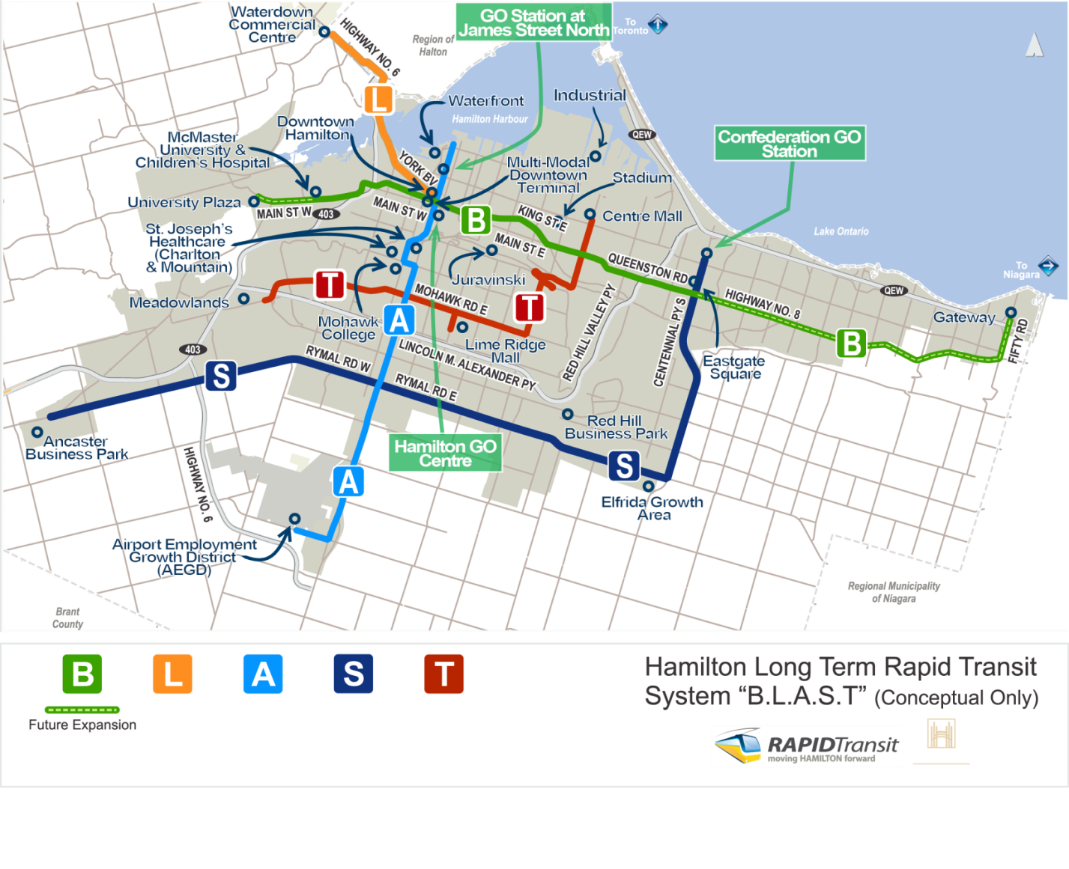
below). There is a plan to implement rapid transit on the A-line from the waterfront to the Airport in the future as funding permits.

- Why wouldn’t industrial areas around Burlington St. be better?
- There were no contiguous parcels of land large enough on Burlington St that were within 1 km of the LRT route which was a major requirement for the OMSF site.

